Task 3 – Part A:

**RSI:** Household Good Stores: All Businesses: VOL SA Percentage on Year Earlier

**Data Source:** Retail Sales Index Time Series (DRSI) - <https://www.ons.gov.uk/businessindustryandtrade/retailindustry/timeseries/idoh/drsi>

**Time Period:** 1989 – 2022

import pandas as pd

import numpy as np

import matplotlib.pyplot as plt

df = pd.read_csv('series-191123.csv')

# Create a time series plot

plt.figure(figsize=(10, 6))

plt.plot(df['Year'], df['RSI'], marker='o', linestyle='-')

plt.title('RSI:Household good stores: All Business - VOL SA Percentage on Year Earlier')

plt.xlabel('Year')

plt.ylabel('RSI - VOL SA Percentage')

plt.grid(True)

plt.show()

# Autocorrelation analysis

def autocorr(x,lags):

    '''numpy.corrcoef, partial'''

    x = np.nan_to_num(x)

    corr = [1. if l == 0 else np.corrcoef(x[l:], x[:-l], rowvar=False)[0][1] for l in lags]

    return np.array(corr)

rsi_data = df['RSI'].to_numpy()

lags = range(1,35)

result = autocorr(rsi_data, lags)

# Plot the autocorrelation values

print("Partial Autocorrelation")

plt.figure(figsize=(8, 5))

plt.stem(lags, result, basefmt="b-")

plt.title('Autocorrelation of VOL SA Percentage')

plt.xlabel('Lag')

plt.ylabel('Autocorrelation')

plt.grid(True)

plt.show()

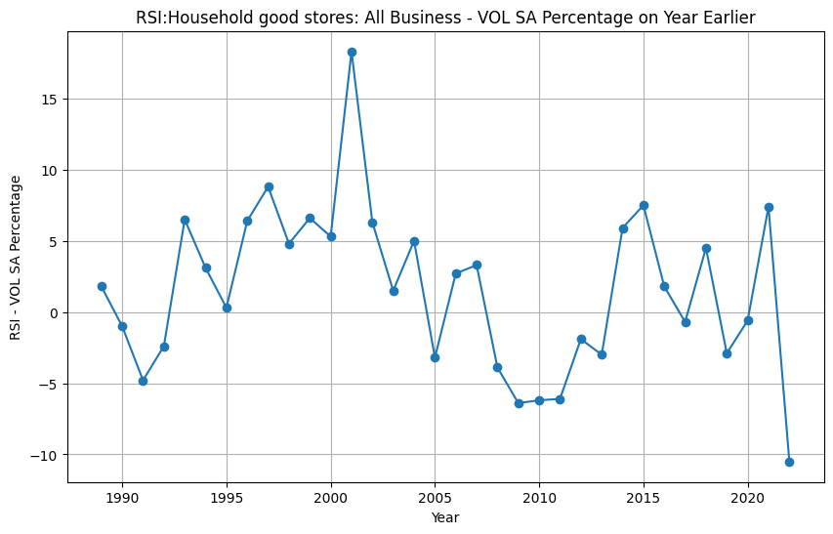

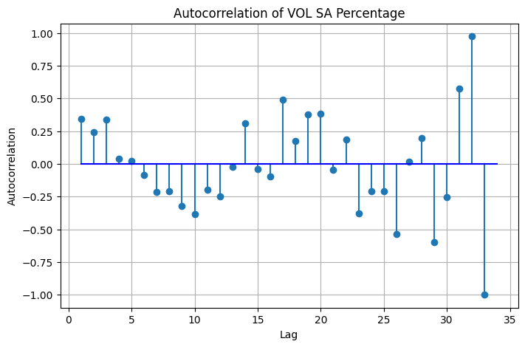

**Explanation:**

The autocorrelation graph shows the correlation between the volatility of a household good store's sales volume over a given period of time and its volatility at previous year step. The graph shows that the autocorrelation is positive at all lags up to 35, meaning that the volatility of the store's sales volume is positively correlated with its volatility at previous year step. In other words, if the volatility of the store's sales volume is high this year, it is more likely to be high next year than if the volatility of the store's sales volume is low this year.

The autocorrelation graph also shows that the autocorrelation of the store's sales volume decreases as the lag increases. This means that the relationship between the volatility of the store's sales volume at the current year step and its volatility at previous year steps becomes weaker as the time lag increases.

From this output, it can be recommended that traders could use this autocorrelation to develop a trading strategy that buys household good store stocks when the volatility of the store's sales volume is low and sells the stocks when the volatility of the store's sales volume is high. This strategy is based on the idea that the volatility of the store's sales volume is mean-reverting, meaning that it tends to return to its average level over time.

Task 3 – Part B:

**The Original Graph**



**Source:** <https://www.bbc.com/news/world-us-canada-41488081>

**Graph with Seaborn**

import pandas as pd

import seaborn as sns

import matplotlib.pyplot as plt

# Load the dataset

data = {

    'Year': [2014, 2015, 2016, 2017, 2018, 2019, 2020, 2021, 2022, 2023],

    'Incidents': [273, 336, 383, 348, 336, 417, 610, 690, 647, 565]

}

df = pd.DataFrame(data)

# Plot the bar graph using seaborn

sns.set_theme(style="whitegrid")

ax = sns.barplot(x="Year", y='Incidents', data=df, color="blue")

sns.despine()

plt.title("Incidents in which four or more people were killed or injured")

# Add text annotations

for p in ax.patches:

    ax.annotate(f'{p.get_height()}', (p.get_x() + p.get_width() / 2., p.get_height()),

                ha='center', va='center', xytext=(0, 10), textcoords='offset points')

last_bar = ax.patches[-1]

last_bar.set_color("lightblue")

plt.show()

Output:

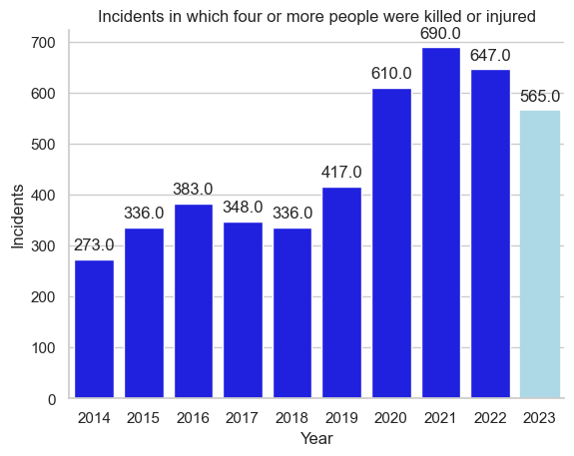

**Graph with plotly**

import pandas as pd

import plotly.express as px

# Load the dataset

data = {

    'Year': [2014, 2015, 2016, 2017, 2018, 2019, 2020, 2021, 2022, 2023],

    'Incidents': [273, 336, 383, 348, 336, 417, 610, 690, 647, 565]

}

df = pd.DataFrame(data)

# Plot the bar graph using plotly

fig = px.bar(df, x="Year", y="Incidents", color_discrete_sequence=["blue"])

fig.update_layout(

    title="Incidents in which four or more people were killed or injured",

)

# Add text annotations

for i in range(len(df)):

    fig.add_annotation(

        x=df['Year'][i],

        y=df['Incidents'][i],

        text=str(df['Incidents'][i]),

        showarrow=True,

        arrowhead=4,

        ax=0,

        ay=-40

    )

fig.update_traces(marker=dict(color=['blue'] * (len(df) - 1) + ['lightblue']))

fig.update_layout(xaxis=dict(tickmode='linear'))

fig.show()

Output:

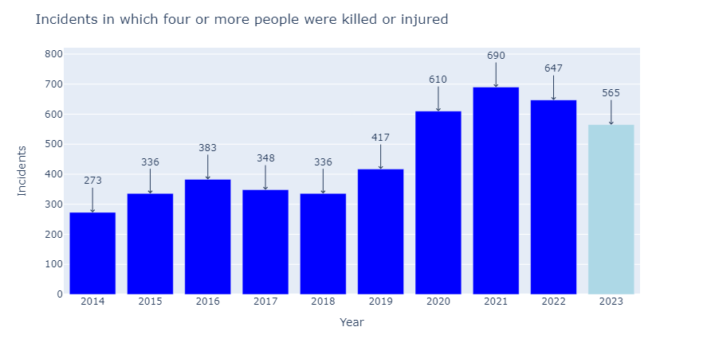

**Storytelling Narrative**

***Context:*** The graph shows the number of incidents in which four or more people were killed or injured in the United States from 2014 to 2023.

***Narrative:***

Over the past few years, the number of incidents in which four or more people were killed or injured in the United States has been steadily increasing. In 2014, there were 273 such incidents. By 2023, that number had risen to 690. This represents a 153% increase over the past nine years.

The trend is particularly concerning because it suggests that the country is becoming increasingly violent. It is also a sign that public safety measures are not effective enough at preventing these types of tragedies.

***Recommendation:***

The relevant decision maker should take steps to address the root causes of mass casualty incidents, such as polarization and mental health crises. They should also invest in public safety measures that are more effective at preventing these types of tragedies.